|  |  |
| --- | --- |
| Course Name | ITD 2313 – Script Programming |
| Instructor | Michael Schnell |
| Student Name | Darion Jones |
| Due date | 6/16/2024 |
| Grade | Put grade earned here |
| Grading Comments | Put instructor comments here |

Module 2 – Scripting Projects

# Pages 50-51

## Project # 1

### Special Instructions:

1. This project is to be done in a python program file. The file needs to be submitted as part of the submission for this assignment. Place the program file into the zip file that is submitted for this assignment.

 Project # 2

### Special Instructions:

1. This project is to be done in a python program file. The file needs to be submitted as part of the submission for this assignment. Place the program file into the zip file that is submitted for this assignment.

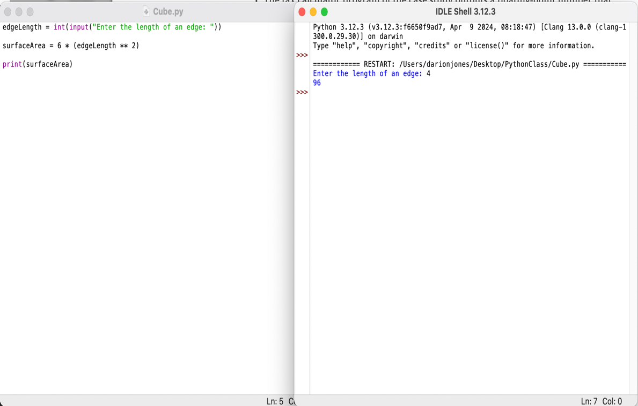

## Project # 4

### Special Instructions:

1. This project is to be done in a python program file. The file needs to be submitted as part of the submission for this assignment. Place the program file into the zip file that is submitted for this assignment.

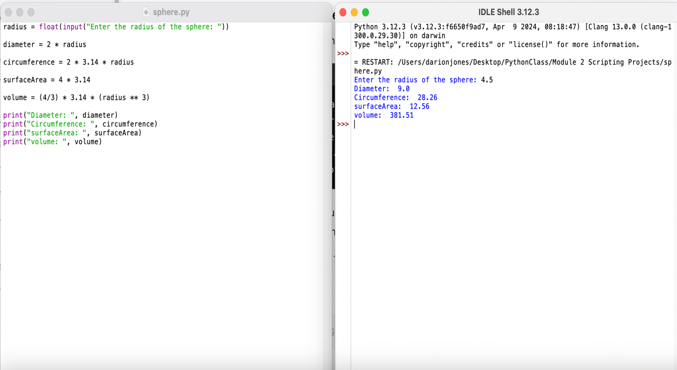

## Project # 5

### Special Instructions:

1. This project is to be done in a python program file. The file needs to be submitted as part of the submission for this assignment. Place the program file into the zip file that is submitted for this assignment.

## Project # 7

### Special Instructions:

1. This project is to be done in a python program file. The file needs to be submitted as part of the submission for this assignment. Place the program file into the zip file that is submitted for this assignment.

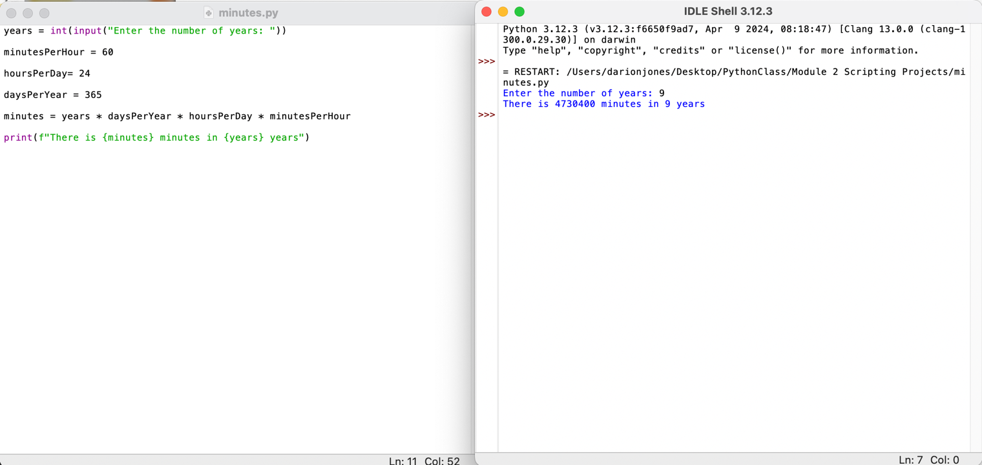

## Project # 10

### Special Instructions:

1. This project is to be done in a python program file. The file needs to be submitted as part of the submission for this assignment. Place the program file into the zip file that is submitted for this assignment.

